# How to read

Medium criticality: Should-have functionality

Low criticality: Nice-to-have functionality

High criticality: Must-have functionality

# Error documenation

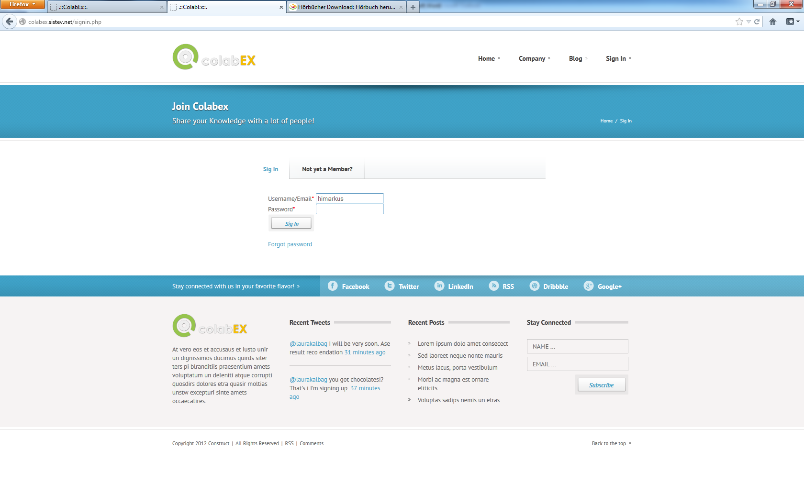

E-001: Enter is not working, have to click on “sign in”.

E-002: Firefox is not asking to save username and password. Why? Usually he asks on every form. He should do that! What are the technical issues preventing that?

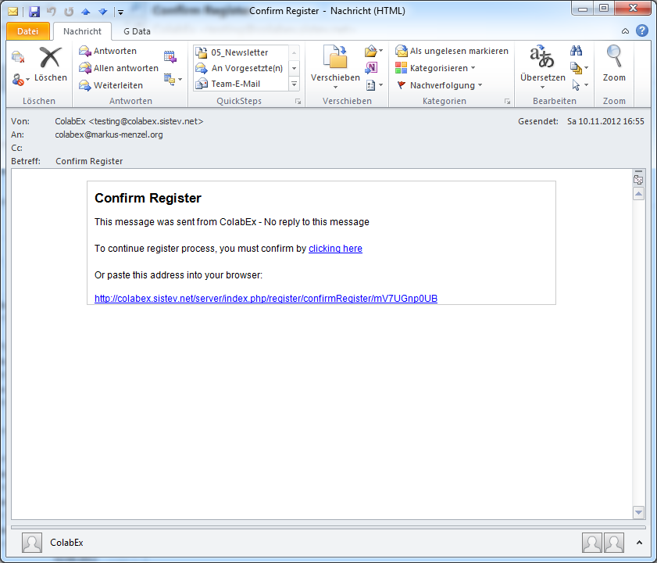

E-004: Layout of registration email:  
Please according to corporate design

E-003: Text of registration email:  
“Please Confirm Registration”  
“ … - Do not reply to this message!”  
“To continue registration process, please confirm your account by clicking here”

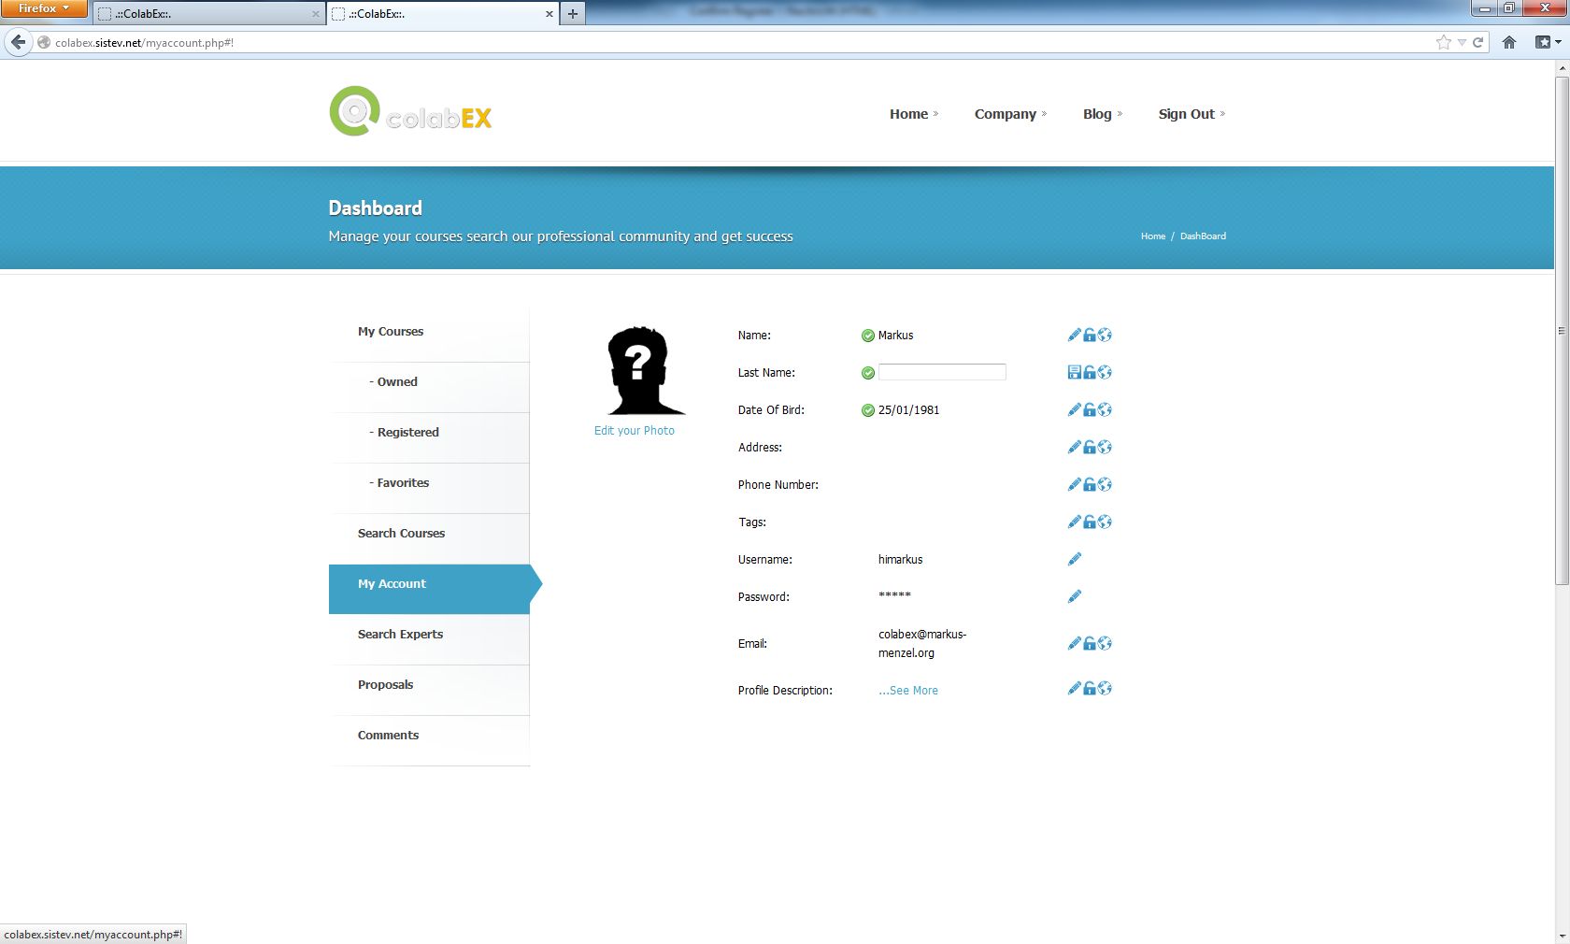

E-005: Email not looking nice. There should be no line break on email-addresses like this.

E-006: Changes should be saved automatically when leaving form (not only explicitly by clicking the “save” button)

E-007: Edit your photo not working  
nothing happens

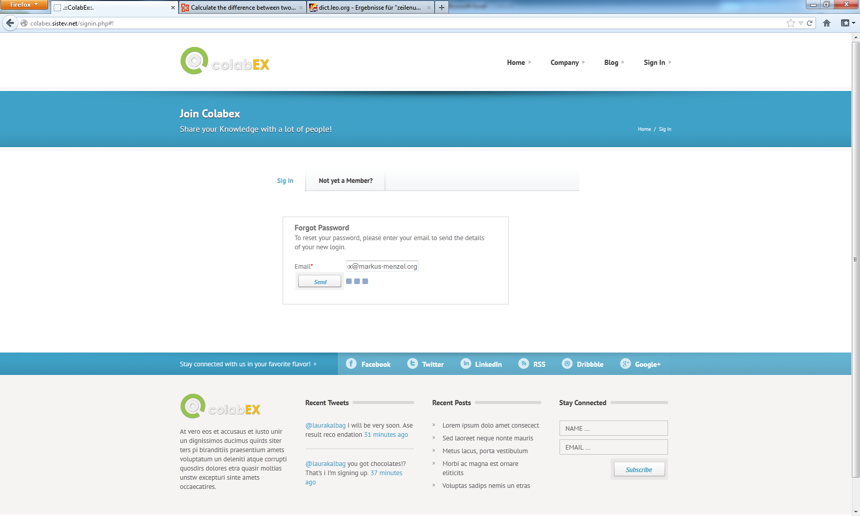

E-008: Nothing happens after clicking on “send”

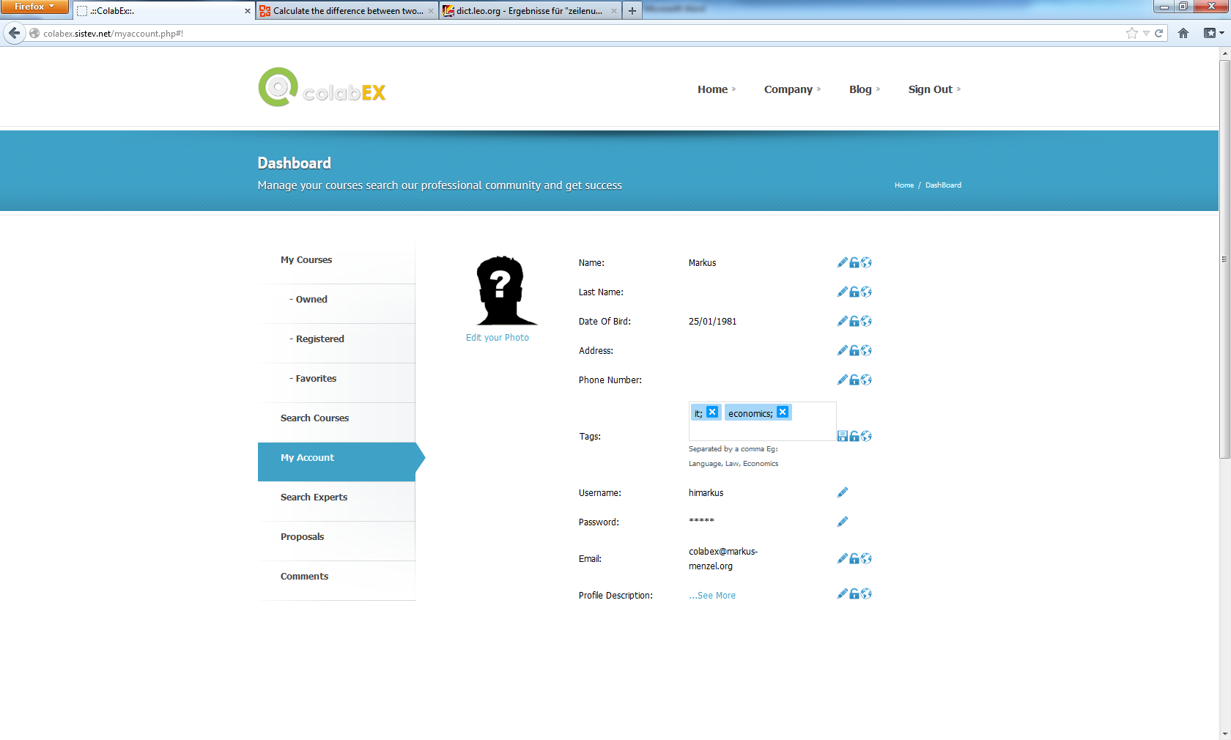

E-009: Do not replace upper case letters (e.g. “IT”) by lower case letters (e.g. “it”). Only treat them internally as identical

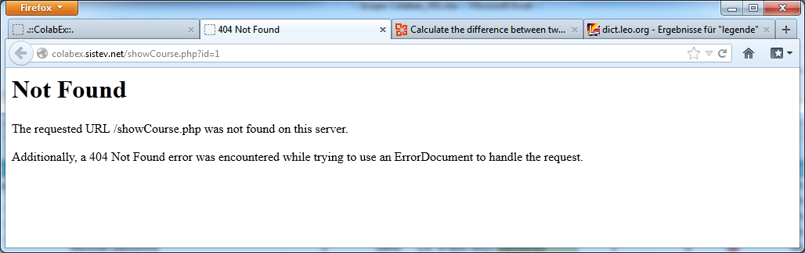

E-010: Not able to open course via search to register.

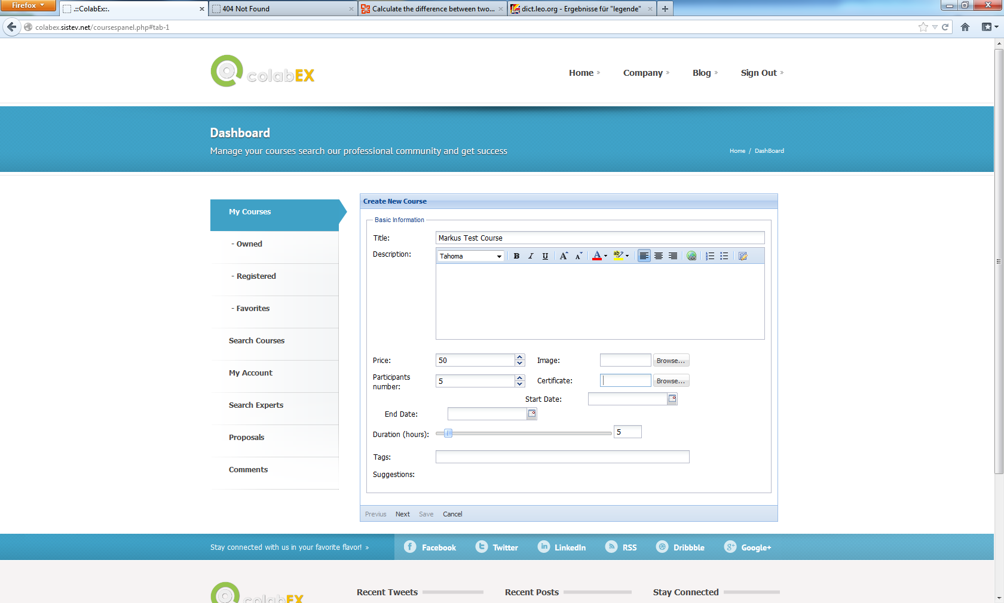

E-015: Dates: Start date can be removed. Dates should be entered one by one (incl. time and timezone!!) after entering one date there should be a “add additional date” line and/or button

E-014: Certificate? What for?

E-013: There should be selection of course type: “podcast” or “regular course”  
**Podcast** only requires: title, description, price, video upload, image, duration (automatically filled after video upload), tags

E-012: Part. Number: Min or Max? Maybe both? --> 2 fields

E-011: Price: There should be a currency displayed (e.g. Euro)

E-016: Duration: Can then be calculated automatically. Please additionally display “number of events” which can also be automatically calculated

# Additionally Remarks

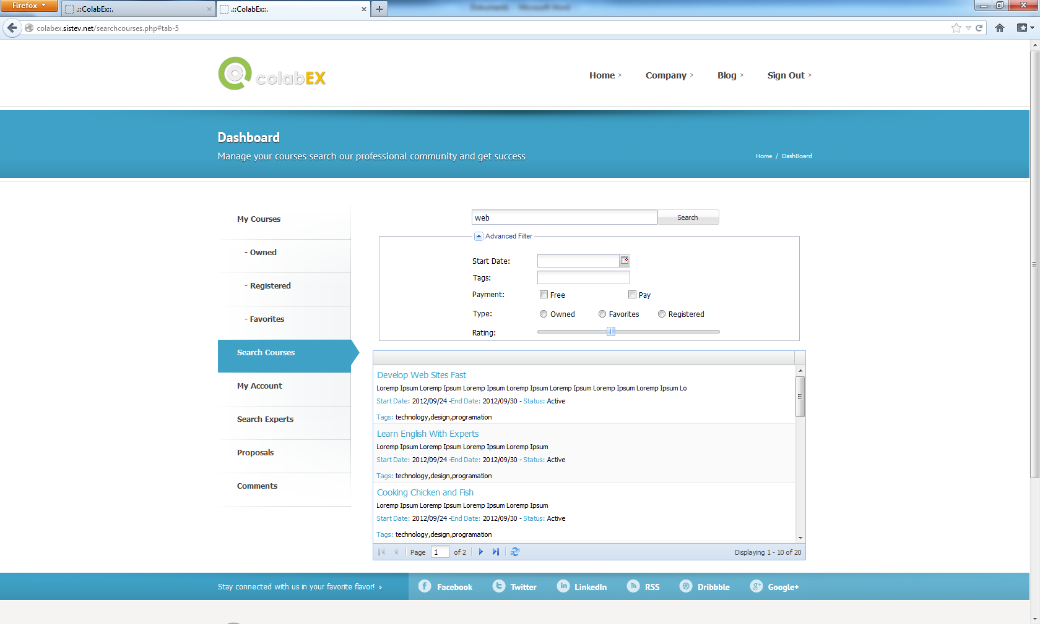

Add checkbox with text “additionally show experts” prechecked

Remove “type” and search options

Prefill today’s date!

Does not search on clicking “search”

Search results should interactively update – while choosing options or entering search text  
(cp. Google search)

Rating should be “star based” with 5 stars maximum.  
(Cp. <http://www.audible.de/>)

Just offer checkbox with text “free courses only”

Live suggestions should be made while entering text (cp. Google search)

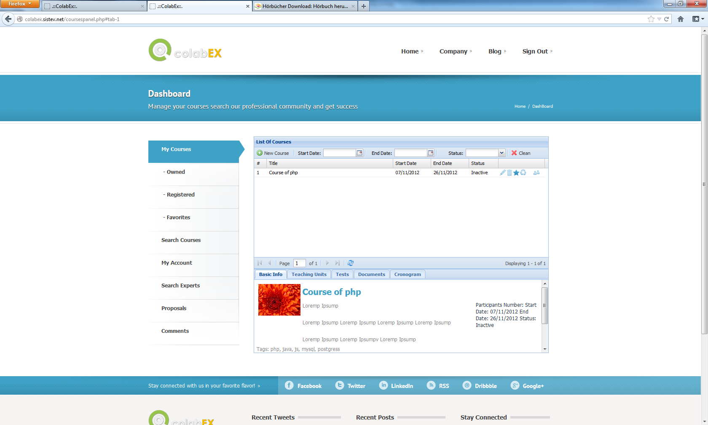

I don’t need “favorites” only show the sup-menus in case there are appropriate courses existing

Remove “search experts”

Put “search courses” on top, then “my courses”

Why does this course show up under “My courses” but not below any of the sub-options (owned, registered, favorites)?

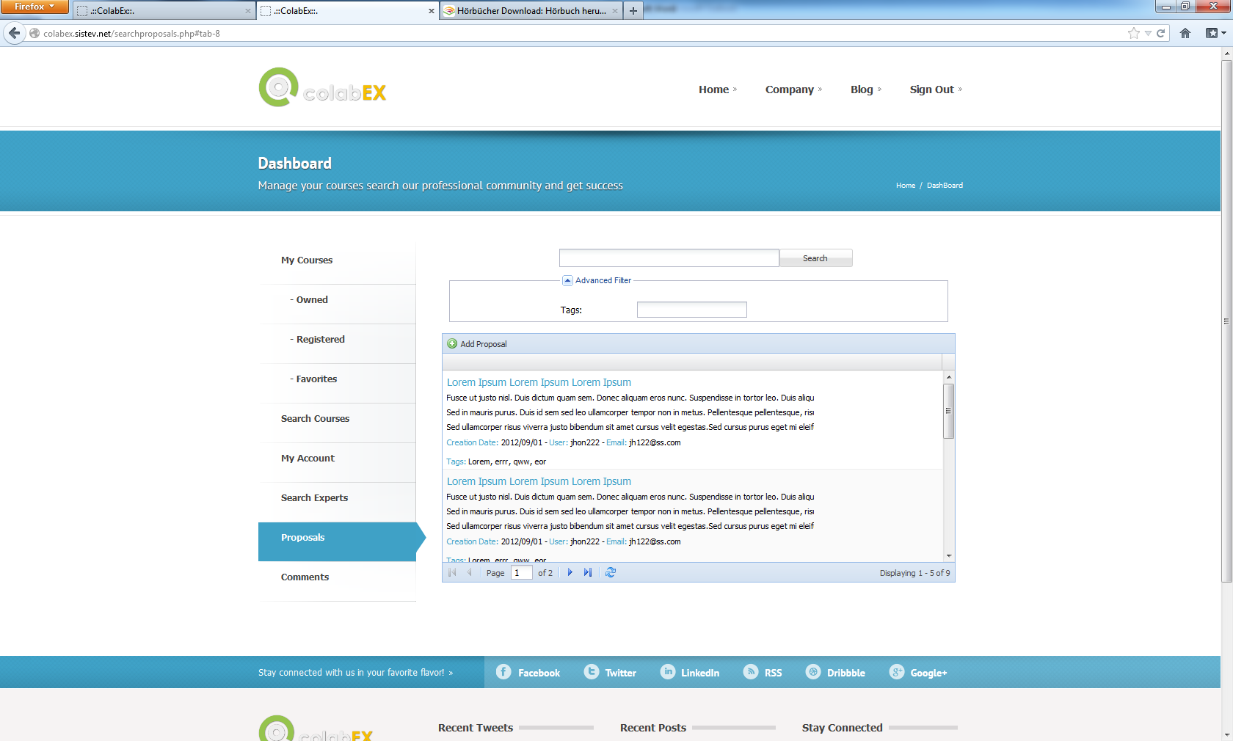

What is that for?



Comments not working!  
What is that for?